

Human Computer Interaction

**Date:** 22nd April 2015  
 **Course Code:** DT211-2  
 **Group:** 20  
  
 **Team Members:** A N Other

A N N Other

**Table of Contents**

Introduction 1

Week 1 1

Interface Chosen 1

Methods of Research 2

Life Cycles 4

Use Case Diagram 5

User Groups 5

Interaction Model 7 Stages of Action) 6

Low Fidelity Prototype 6

Week 2 7

Enhanced Low Fidelity Prototype 8

Cognitive Processes 9

Cognitive Frameworks (mental models/metaphors) 9

Cognition Techniques 9

Interaction styles 10

Input and Output devices 10

Evaluation of Low Fidelity Prototype 10

Results of Evaluation 11

Week 3 12

Medium Fidelity Prototype 12

Groupware Elements 13

Conclusions 13

Evaluations 14

**Introduction**

**Paragraph**

**Week 1**

**Interface chosen**

JPG

sentence

**Methods of Research:**

Paragraph

**Internet research:**

Half a page with examples

**Interview Users or Questionnaire:**

5 – 10 questions

**Life Cycle:**

EG The Star Life Cycle is…

Paragraph.

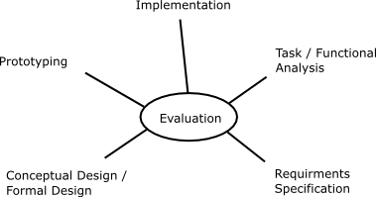

**Use Case Diagram:**

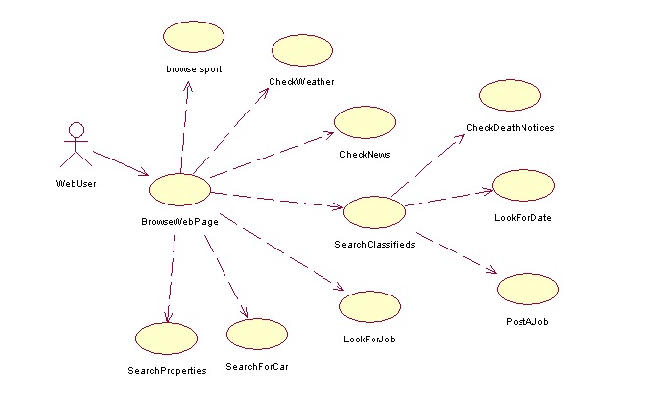

Above is a simple use case of our low fidelity prototype.

**USER GROUPS:**

The user groups that this website is focused on would be …

Paragraph

**Interaction Models 7 stages of action:**

|  |  |
| --- | --- |
| Forming the goal: | ? |
| Forming the intention: | ? |
| Specifying the action: | ? |
| Executing the action: | ? |
| Perceiving the state of the world: | ? |
| Interpreting the state of the world: | ? |
| Evaluating the outcome: | ? |

This interface has a gulf of evaluation…

**Low Fidelity Prototype:**

Below is an image of a low fidelity prototype which was drawn on a sheet of paper

JPG – a photo of Low Fidelity Prototype

**Enhanced low fidelity prototype**

Paragraph introducing several photos

MAIN (HOME) PAGE

? PAGE

? PAGE

? PAGE

**Issues**

Half page

**Mental Model:**

Paragraph

**Metaphors:**

Paragraph

**Techniques to aid cognition:**

**Perception:**

A Line or two.

**Attention**:

A Line or two.

**Memory:**

A Line or two.

**Learning:**

A Line or two.

**Interactive Styles**

A Line or two.

**I/O Devices**

A Line or two.

**Evaluation of Low fidelity prototype 2**

A paragraph.

**Results of Evaluation**

A page

**Medium fidelity prototype**

A paragraph.

**A GIF or two or JPGs.**

**Groupware:**

Groupware worked in this project example

**Conclusion**

A few short paragraphs

**Team Performance:**

I believe that our team…

A few short paragraphs